BUREAU 2018

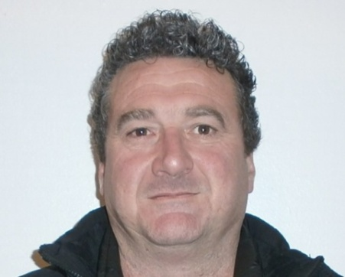

**FLORIAN MURAT – PRESIDENT**

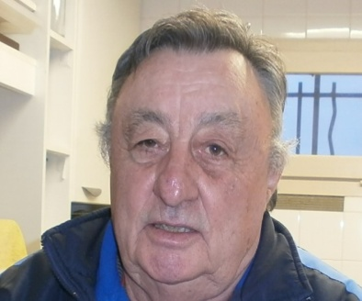

**MICHEL BERTEL - TRESORIER –VICE PRESIDENT**



**REGINE ARESE SECRETAIRE –TRESORIERE ADJOINTE**

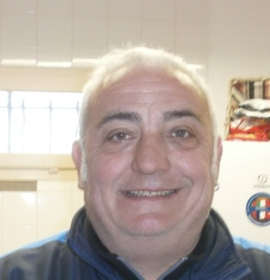

**ERIC AUGIS – RESPONSABLE SPORTIF**